Technical Report - Vizionaries

Data:
- We had 2 datasets - application_data and previous_application
- application_data had 307511 rows and 122 columns
- previous_application had 1670214 rows and 37 columns

Data Preprocessing:

Application Data:
- Replaced XNA and XAP as null values
- Removed 49 columns which had more than 47% null values
- Numeric columns filled with median
- Categorical columns filled with “Unknown”

Previous Application Data:
- Replaced XNA and XAP as null values
- Removed 3 columns which had more than 85% null values

Merging Previous Application with Application Data:
- In Previous application, Aggregated count of each category in NAME_CONTRACT_STATUS, NAME_CONTRACT_TYPE and CODE_REJECT_REASON as separate columns
- Mean of is_approved taken
- AMT_CREDIT - mean and max taken
- AMT_ANNUITY - mean
- DAYS_DECISION - min and max
- critical_reject_count = prev_hc_reject_count + prev_sco_scofr_reject_count + prev_limit_reject_count

Left Joined with application_data on SK_ID_CURR column.

Outliers:
Treating them in 3 groups:
- Amounts: `AMT_GOODS_PRICE`, `AMT_CREDIT`, `AMT_ANNUITY`, `AMT_INCOME_TOTAL`, `CNT_CHILDREN`, `CNT_FAM_MEMBERS` - capped at upper value of iqr
- Time: `DAYS_BIRTH`, `DAYS_EMPLOYED`, `DAYS_REGISTRATION` - made specific changes
  - DAYS_EMPLOYED - 365243 - this value treated a null because this denotes no employment
  - DAYS_BIRTH and DAYS_REGISTRATION converted to positive values and to years.
- Behaviour counts: `prev_application_count`, `critical_reject_count`, `loan_rejected_or_cancelled_count` - kept as is

Analysis:

Derivations for analysis:
- Computed weighted sum of "EXT_SOURCE_2" and "EXT_SOURCE_3"
- Found these columns to be the top 20 most correlated with target
['EXT_SCORE_WEIGHTED', 'EXT_SOURCE_2', 'EXT_SOURCE_3', 'DAYS_BIRTH',
'AGE_YEARS', 'DAYS_EMPLOYED', 'critical_reject_count',
'prev_approved_ratio', 'REGION_RATING_CLIENT_W_CITY',
'REGION_RATING_CLIENT', 'DAYS_LAST_PHONE_CHANGE',
'prev_min_days_decision', 'loan_rejected_or_cancelled_count',
'DAYS_ID_PUBLISH', 'REG_CITY_NOT_WORK_CITY', 'prev_hc_reject_count',
'NOT_EMPLOYED_FLAG', 'FLAG_EMP_PHONE', 'revolving_loans_count',
'REG_CITY_NOT_LIVE_CITY', 'FLAG_DOCUMENT_3']

The External Source Score Index:
Our analysis shows that normalized scores derived from external data sources, particularly EXT_SOURCE_2 and EXT_SOURCE_3, exhibit the strongest correlation with borrower default rates among all variables examined.
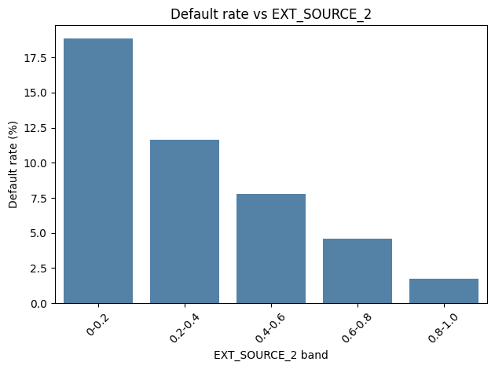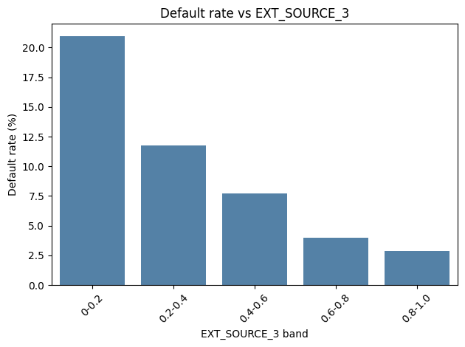
The graphs above illustrate our findings. Both external source scores were able to identify more than 8% (global average) of defaulters among applicants with scores up to 0.6.
Using this information we developed a correlation weighted composite risk index using these two variables which resulted in even better results as visualized below.
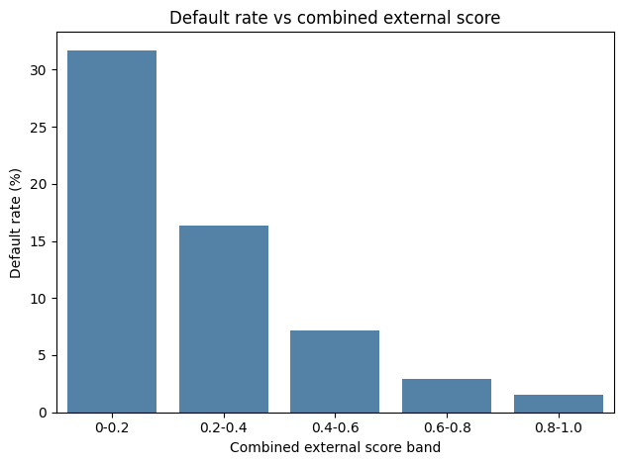

This composite index outperforms the individual external scores by identifying defaulters up to 30% within the 0 - 0.2 score band.

Below is the code snippet used to formulate the correlation weighted composite risk index.
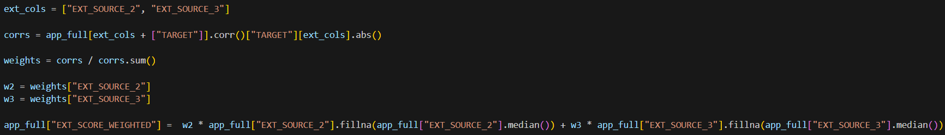

Correlation:
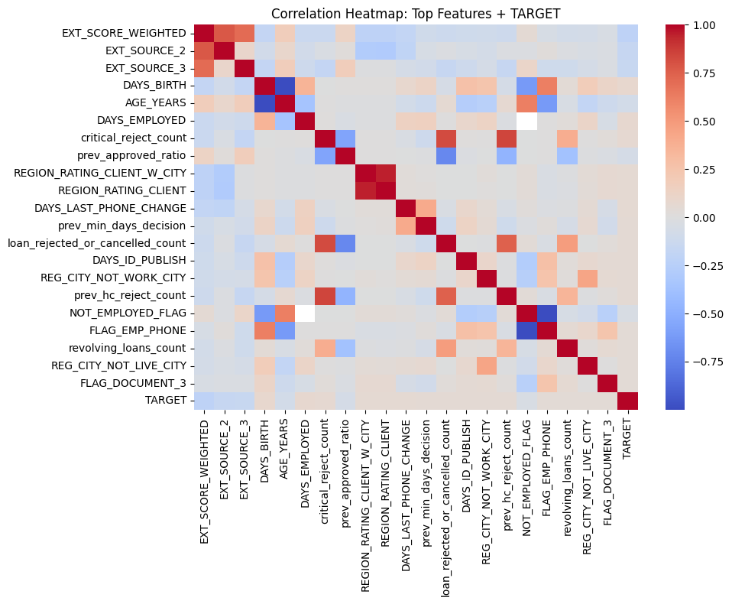

1. Region rating categories:
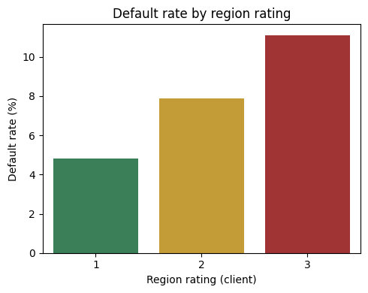

2. prev_min_days_decision (recency of earliest previous app)
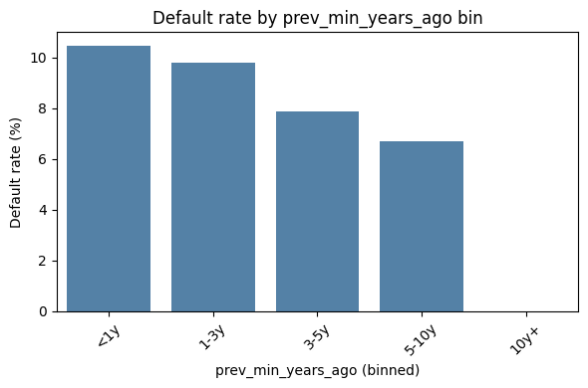

3. Count features
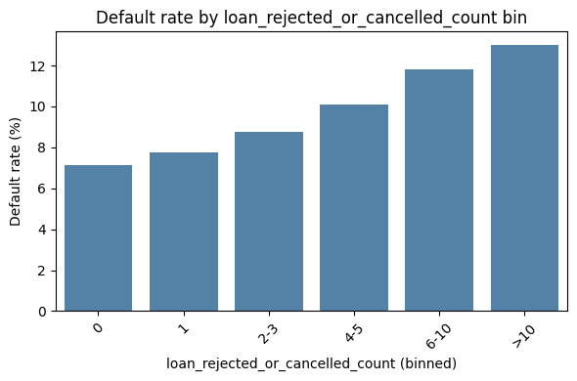
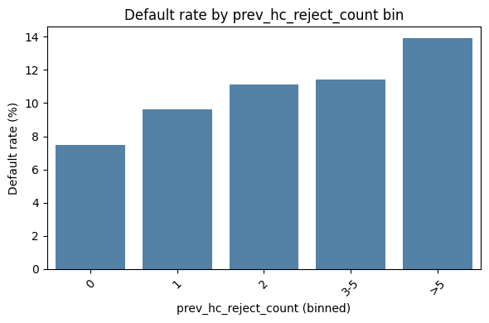
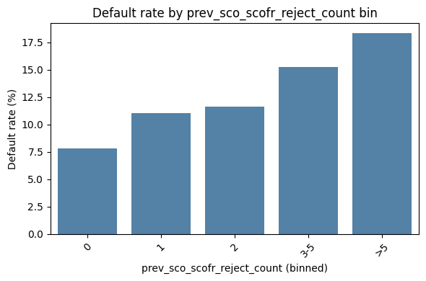
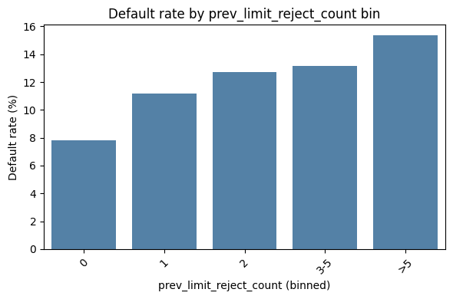

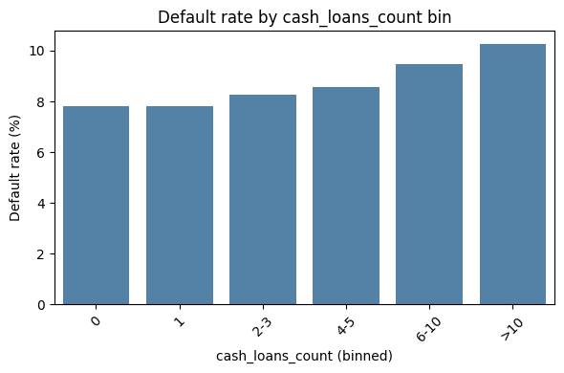
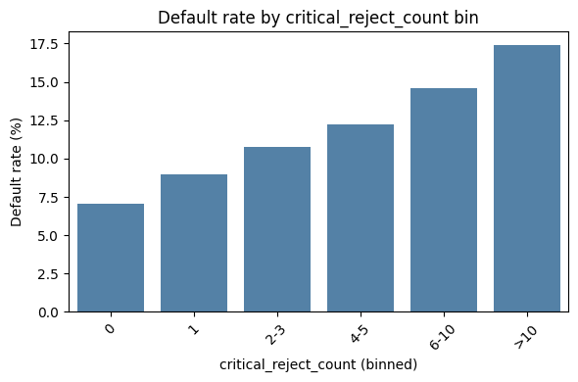

4. Income band × loan_rejected_or_cancelled_count (heatmap)
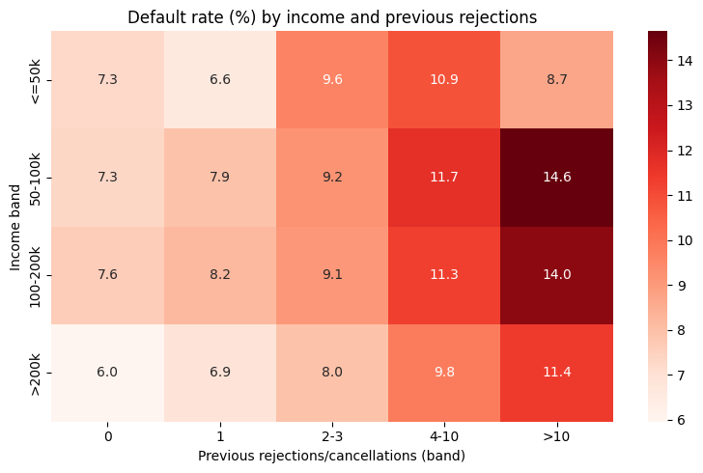

5. Income band × prev_approved_ratio
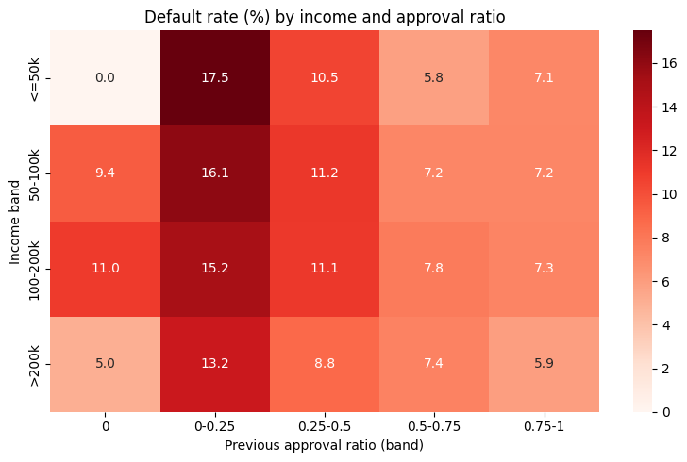

Questions

A) Customer Profile Questions

1. How does the default rate vary with age?
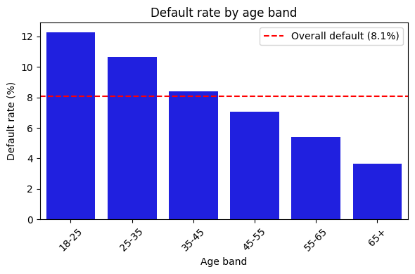

2. Do customers with lower income have higher default rates?
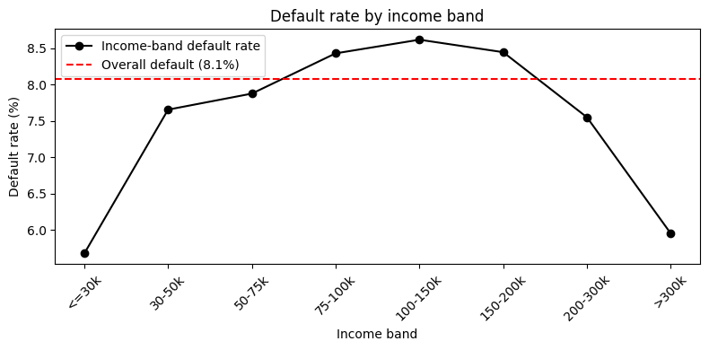

3. Is default more common among certain employment types?
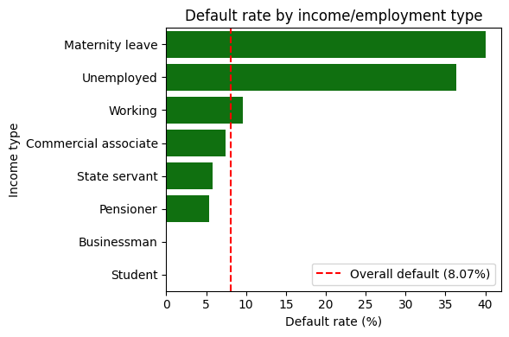

4. Do borrowers with more dependents (children/family size) default more?
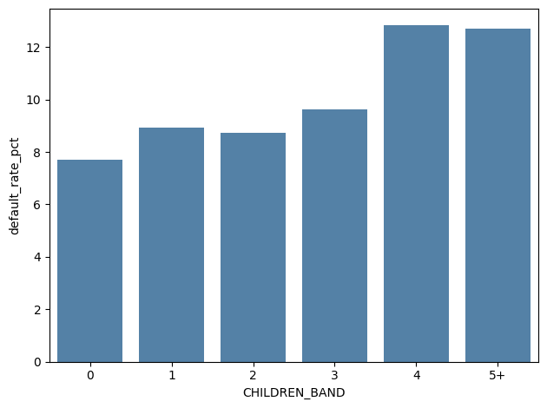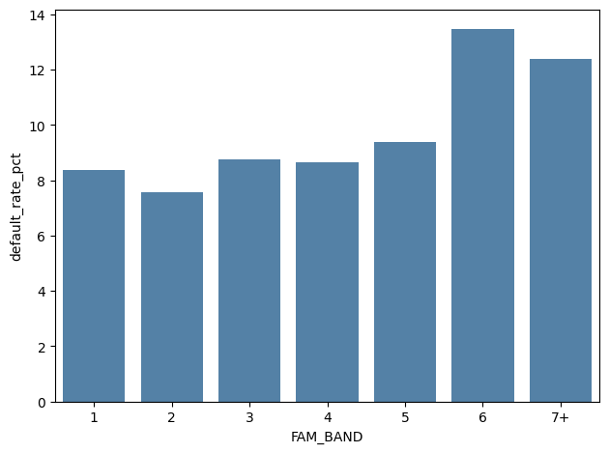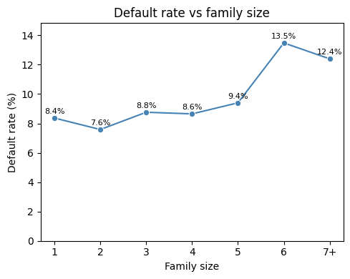

5. What is the impact of education level on repayment?
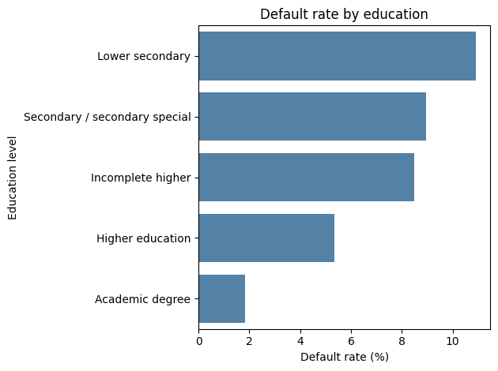

B) Loan Structure Questions

6. How does loan amount relate to default risk?
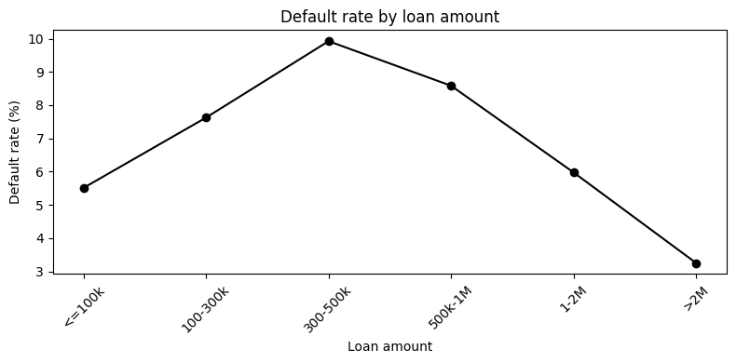

7. Do high EMIs (AMT_ANNUITY) lead to more defaults?
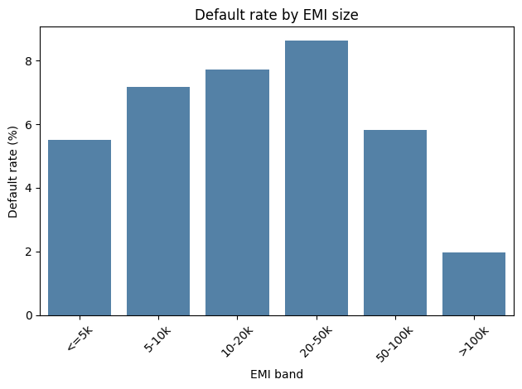

8. Are certain contract types (cash vs revolving) riskier?
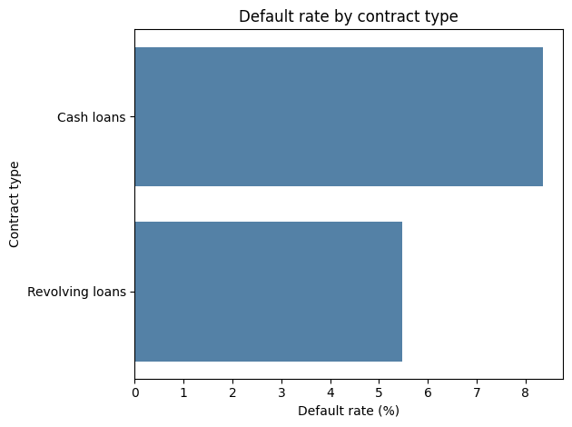

B) Loan Structure Questions

9. Is there a link between credit bureau enquiries (recent loan shopping) and default?
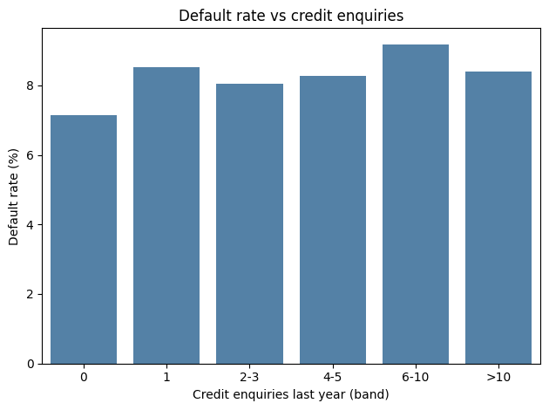

10. Does owning a house or car reduce default risk?
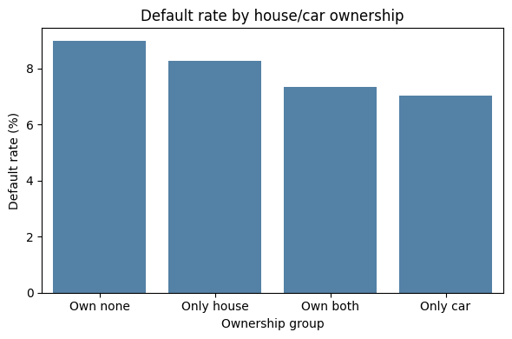

D) Past Loan Behavior (Previous Application)

11. Are customers with previously rejected loans more likely to default now?
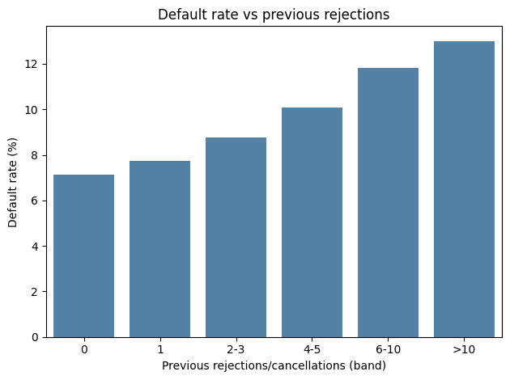
12. Does requesting a very high Requested vs Approved ratio indicate risk?
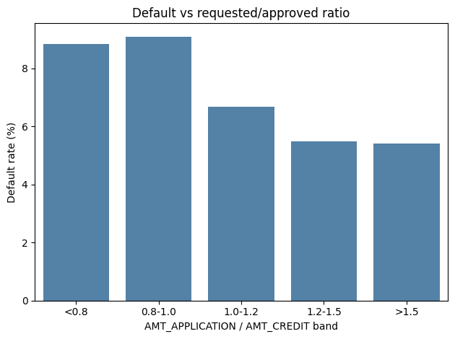

13. Does frequent loan application behaviour (multiple previous loans) predict default?
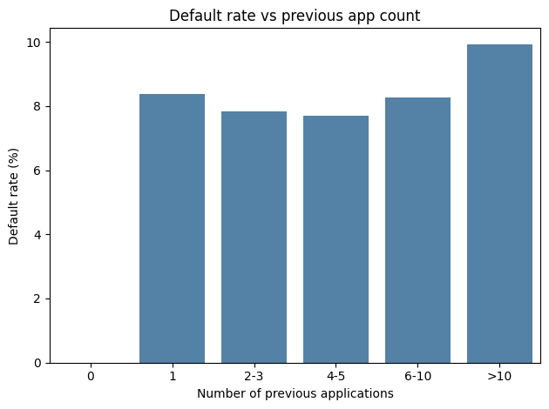

Dashboard:
The dashboard was created using Plotly Dash to visually analyse loan repayment behaviour and identify key drivers of default risk. The data was first cleaned and transformed by grouping important variables such as age, income, loan amount, EMI burden, credit bureau activity, and previous loan behaviour into meaningful bands to improve interpretability.
The dashboard compares default rates across these segments, highlighting how affordability, financial stability, external credit scores, and past loan outcomes influence repayment risk. Interactive filters allow users to explore different customer profiles, making the dashboard both descriptive and exploratory, and supporting more informed loan approval decisions.

Attaching screenshots from the dashboard below:

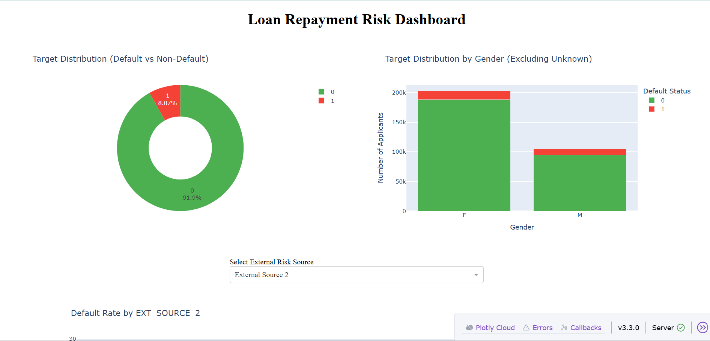

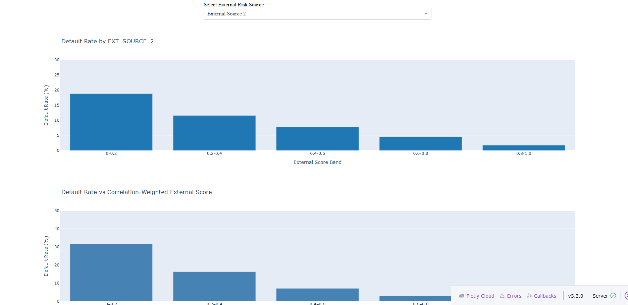


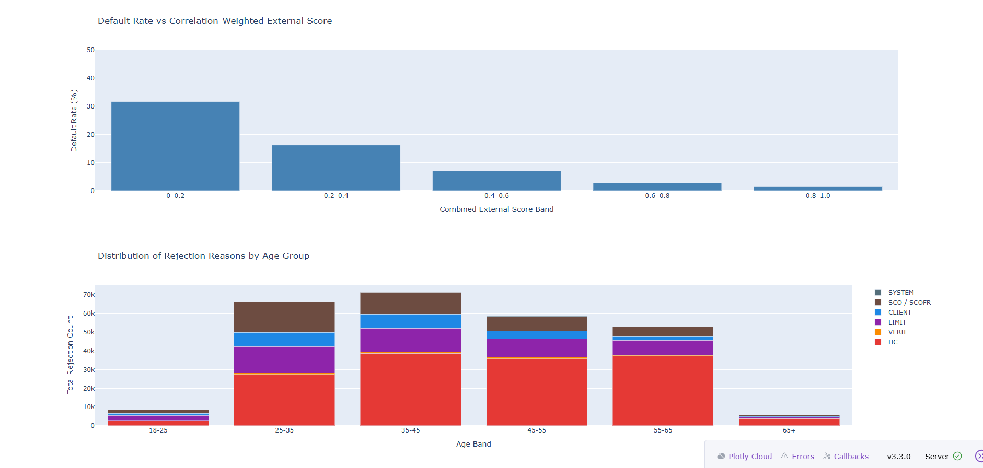

This chart (distribution of rejection reasons by age group) shows the distribution of rejection reasons across different age groups. It highlights that rejection counts are higher among middle-aged applicants, with credit-related and verification-related issues being the most common reasons, while younger and older age groups have comparatively fewer rejections.

Insights from the Data
- Unemployed applicants have previously defaulted 36% of times. This is almost 4 times higher than working applicants who default 9.6%.
- Applicants of the age group between 18 - 25 have the highest default rate. The trend of age group vs defaulter rate suggests risk of defaulting reduces with increasing age.
- Applicants with Income <50k who have been approved 25% of time previously default ~17% of the time.
- Applicants with 6+ previous rejections default more than 10% of time. This is a strong behavioral signal of such applicants.
- Applicants with external score <0.3 are likely to default by 15-20% on average.
- High EMI (>50k): High risk.
Recommendations
- Apply stricter scrutiny for unemployed applicants.
- Consider requiring additional collateral, guarantors, or proof of alternative income before approval.
- Offer smaller loan amounts or shorter tenures to reduce exposure.
- For younger applicants, conduct additional checks on income stability and repayment capacity.
- Apply stricter affordability assessments for low-income applicants.
- Consider lower loan amounts or staggered disbursements to reduce exposure.
- Treat multiple previous rejections as a strong behavioral red flag.
- Cap EMIs relative to applicant’s income (e.g., EMI should not exceed 40–50% of monthly income).
General Risk Strategy
- Safe: Low risk based on employment, age, income, and credit score.
- Review Needed: Moderate risk, e.g., young employed applicants with moderate income.
- High Risk: Unemployed, low external score, multiple previous rejections, high EMI.
The external score correlation weighted composite risk index presented in this report, or a composite index derived from the most significant variables identified in our analysis, can be developed into a practical tool for assessing an applicant’s likelihood of default. This index would enable more effective risk segmentation, helping the company reduce default rates while simultaneously expanding lending to creditworthy, low-risk borrowers who might otherwise be overlooked.

